Websites Guidelines and Standards
Jordan Government Websites Guidelines 2019
Ministry of Digital Economy and Entrepreneurship

Version: V16.0 Approved
Submission Date: 20/8/2019

Prepared By

Proprietary Information
Echo Technology LLC. and Echo Soft Technology, Al-Sada lel tecnologya and Echo Technology Logo registered trademarks. Other trademarks and trade names may be used in this document to refer to either the entities claiming the marks and/or the names of their products. Echo Technology disclaims proprietary interest in the marks and names of others.
The information in this document has been reviewed and is believed to be accurate. However, neither Echo Technology nor its affiliates assume any responsibility for inaccuracies, errors, or omissions that may be contained herein. In no event will Echo Technologies or its affiliates be liable for direct, indirect, special, incidental, or consequential damages resulting from any defect or omission in this document, even if advised of the possibility of such damages.
Echo Technology reserves the right to make improvements or changes to this document and information contained within, and to the products and services described at any time, without notice or obligation.
Echo Technology LLC. understands that any award to supply the products / provide the services that are the subject of this proposal are subject to the mutual execution of a definitive written agreement.
All information supplied for the purpose of this document is to be considered Echo Technology confidential.
This Proprietary Information, presented on this page, is an integral part of this document. Should this page of the document, in its electronic or printed formats, be lost, deleted, destroyed or otherwise discarded, this disclaimer statement applies despite the consequences. © Copyright Echo Technology LLC. (2019)

Document History
Document Properties
Item | Details
Released for | Ministry of Digital Economy and Entrepreneurship
Project Name | Jordan Government Websites Guidelines 2019
Classification | Limited Distribution
Ref # | GWS_2019-Modee-v14 0-En
Author | Echo Technology
Creation Date | 5/6/19
Last Update | 20/8/19

Change History
Version | Date | Summary of Change | Updated by | Comments
V10.0 | 7/7/19 | Approve and Release | Yousef Alem
V10.1 | 5/8/19 | Update Section 7  Update Section 3.4  Update Section 5.5  Update all Guidelines with  “Website Service Category”  Section 3.8 is added  Section 7.10 is added | Echo Team
V11.0 | 7/8/19 | Approve and Release | Yousef Alem
V12.0 | 18/8/19 | Update Section 7  Update Section 5.8  Release | Yousef Alem
V13.0 | 20/8/19 | General Overview | Echo Team
V14.0 | 20/8/19 | Change Document  Classification | Yousef Alem
V16.0 | 20/8/19 | Proofing | Yousef Alem

Approval
Version | Date | Approved by | On behalf of | Status

Table of Contents

Glossary Terms ................................................................................................................................................................... 9
Executive Summary ................................................................................................................................................ 11
Introduction ............................................................................................................................................................. 13
Jordan Government Website Standards v1.0 ........................................................................................ 13
How to Use this Document ........................................................................................................................ 15
Suggestions and Enhancement ................................................................................................................ 15
Accessibility .............................................................................................................................................................. 16
Domain Naming Conventions and Uniform Resource Locators ..................................................... 16
Domain Name Structure ........................................................................................................................ 16
Naming Conventions .............................................................................................................................. 17
Domain Binding and Access Protocols .............................................................................................. 17
Directory Path and Page Names ......................................................................................................... 18
Discoverability and Search Engine Optimization ................................................................................. 19
Cross Browsing and Screen Resolution .................................................................................................. 21
Access to Language ..................................................................................................................................... 22
Accessibility Actions ..................................................................................................................................... 23
Enable Social Media ..................................................................................................................................... 25
RSS Feeds Subscription ............................................................................................................................... 26
Web Performance ........................................................................................................................................ 26
Usability and Design .............................................................................................................................................. 28
Site Navigation and Effective Sitemap .................................................................................................... 28 Site Menus .................................................................................................................................................. 29 Page Side Menus ...................................................................................................................................... 32
Breadcrumbs Bar ...................................................................................................................................... 33
Tab Navigation.......................................................................................................................................... 33
Return to Homepage ..............................................................................................................................34
Sitemap .......................................................................................................................................................34
Homepage ...................................................................................................................................................... 35
Search Functionality ..................................................................................................................................... 38
The Use of Icons - Iconography ...............................................................................................................40
Images for Web .............................................................................................................................................43
Web Forms .................................................................................................................................................... 44
Animation........................................................................................................................................................ 47
Web Design ....................................................................................................................................................48
Content and Site Architecture ............................................................................................................................49
Sitemap ............................................................................................................................................................49
Site Pages ........................................................................................................................................................ 52
Informative Site Pages ............................................................................................................................ 52
List ................................................................................................................................................................ 56
Services Guide ........................................................................................................................................... 57
Branches Guide .................................................................................................................................... 58
Downloadable Files ...................................................................................................................................... 59
Contact Information ..................................................................................................................................... 60
Cross Government Information ................................................................................................................ 61
FAQ ................................................................................................................................................................... 62 Website Policies............................................................................................................................................. 63
Privacy Policy ............................................................................................................................................. 63
Copyrights .................................................................................................................................................. 65
Copyrights Statement ............................................................................................................................. 66
Terms of Use ............................................................................................................................................. 66
Disclaimer ................................................................................................................................................... 68
Content Management System .................................................................................................................. 69
Responsive Web Design ...................................................................................................................................... 71
Design for Mobile ......................................................................................................................................... 72
Content ............................................................................................................................................................ 77
Website Security ..................................................................................................................................................... 79
OWASP Top 10 .............................................................................................................................................. 80
HTTPS Protocol ............................................................................................................................................. 83
Software Updates .........................................................................................................................................84
Restrict File Uploads .....................................................................................................................................84
Using Captcha ............................................................................................................................................... 85
Users Passwords ............................................................................................................................................ 86
Viruses and Malware .................................................................................................................................... 87
Adjust Default Settings ................................................................................................................................ 87
Error Messages .............................................................................................................................................. 87
Secure APIs ..................................................................................................................................................... 88

List of Tables
Table 1 - Meta Tags Types ............................................................................................................................................ 20
Table 2 - Accepted Browsers Versions ..................................................................................................................... 21
Table 3 - Types of Disabilities ......................................................................................................................................24
Table 4 - Homepage Components. ........................................................................................................................... 38
Table 5 - Government Website Minimum Content ............................................................................................... 50
Table 6- Cross Government Information ................................................................................................................. 62
Table 7- Mobile Menus ................................................................................................................................................. 73
Table 8 - Website Security............................................................................................................................................ 80

Table of Figures

Figure 1- GWS guidelines overview............................................................................................................................ 14
Figure 2 : Domain Name Structure ............................................................................................................................ 17
Figure 3 - Font Resizing Action Icons ........................................................................................................................24
Figure 4- Serial Position Effect in Arabic Website .................................................................................................. 30
Figure 5 - Serial Position Effect in English Website. .............................................................................................. 30
Figure 6 - Secondary Menu Items .............................................................................................................................. 32
Figure 7 - Page Side Menu .......................................................................................................................................... 32
Figure 8 - Tab Navigation in English ......................................................................................................................... 33
Figure 9 - Trade Services Support Icons ..................................................................................................................40
Figure 10 - Action Icons ................................................................................................................................................. 41
Figure 11 - Icons Sets ......................................................................................................................................................42
Figure 12 - Sitemap Arabic Version ........................................................................................................................... 50
Figure 13 - Sitemap English Version .......................................................................................................................... 51
Figure 14 - About Us Example ..................................................................................................................................... 53
Figure 15 - Responsive Web Design .......................................................................................................................... 71
Figure 16 - Standards and Responsive Website Pages......................................................................................... 72
Figure 17 - reCAPTCHA v2 by Google ...................................................................................................................... 85

Glossary Terms
Abbreviations | Description
GWS | Government Websites Standards
URL | Uniform Resource Locators
DNS | Domain Name System
TLD | Top-Level Domain
SLD | Second-Level Domain
XML | Extensible Markup Language
SEO | Search Engine Optimization
HTML | Hypertext Markup Language
HTTP | Hypertext Transfer Protocol
TTFB | Time to First Byte
CSS | Cascading Style Sheet
PDF | Portable Document Format
SVG | Scalable Vector Graphics
PNG | Portable Network Graphic
CVV | Card Verification Value
SMS | Short Message Service
GWDK | Jordan Government Website Design Kit
IA | Information Architecture
FAQ | Frequently Asked Questions
CMS | Content Management System
OWASP | Open Web Application Security Project
HTTPS | Hypertext Transfer Protocol Secure
API | Application Programming Interface
SQL | Structured Query Language
IP | Internet Protocol
ALT Value | Alternative Value
XEE | XML External Entities

JSON | JavaScript Object Notation

Executive Summary
The Government of Jordan has moved its approach of services delivery toward online channels. A close look at the government websites reveals that most of the important government entities have already established an advanced presence on the internet.
However, these websites follow different technology standards, design layouts, navigation architecture, or in simple terms, different look and feel as well as functionality. This variety requires from the common website visitors to familiarize himself/herself with the functionality of each website, which results in a lot of inconvenience, thus defeating the very purpose of these websites.
The Jordan Government Websites Standards (GWS) aims to make the Jordanian government websites more usable, user-centric and universally accessible. Additionally, it will bring uniformity in the quality of content and provided services.
The Jordan Government Websites Standards (GWS) addresses the website design, structure, navigation and content writing common issues that government entities face during development and management of their websites throughout (36) Guidelines, categorized under (5) Components, which are:
- Accessibility (8 Guidelines)
- Usability and Design (8 Guidelines)
- Content and Site Architecture (8 Guidelines)
- Responsive Web Design (2 Guidelines)
- Web Security (10 Guidelines)
Compliance to these guidelines will ensure a high level of consistency and uniformity in the content coverage and presentation that will lead to further excellence promotion in the Jordanian Government web space, whereby all government entities are strongly encouraged to comply with these guidelines.

Introduction
Jordan’s digital presentation has increased tremendously in the past few years. Mobile phones and websites are becoming widely used media for the delivery of services and information to the public.
The need for standardization and uniformity in websites belonging to the government is turning into a must, whereby the standards and guidelines aim to make the Jordanian Government websites more usable, user-centric and universally accessible, in addition to bringing uniformity to the quality of content and provided services.

Jordan Government Website Standards v1.0
This version is the first to be released of the
Jordan Government Websites Standards (GWS), which was prepared by the Ministry of Digital
Economy and Entrepreneurship and Echo Technology.
This version of the standards is an outcome of studies done on well-known international standards and recommendations, in addition to users and organizations feedback, surveys and users’ behavior analysis performed by Echo Technology, where the main inputs to prepare this document were the following:
- The Government Identity.
- The Government Needs.
- The Websites Visitor’s Needs.
- The Websites Visitors’ Technology.
- The Websites Visitors’ Behavior and Expectations.
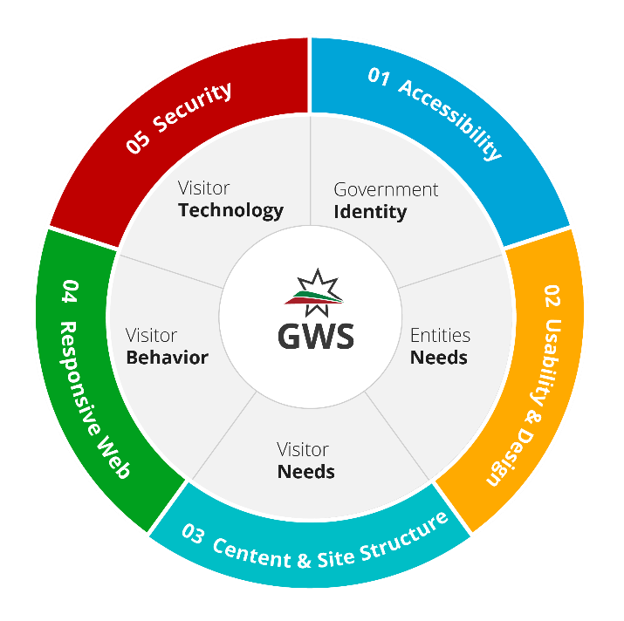
This GWS consists of (36) Guidelines, categorized under (5) Components.
Compliance with these guidelines will not only enhance the quality of the entities’ websites but also help in making them easy to use and customer-focused:
Accessibility (8 Guidelines): A government website serves a largely heterogeneous population that comprises users with vastly
Figure 1- GWS guidelines overview different learning styles and capability levels.
The accessibility guidelines are meant to make the website inclusive and accessible to the widest possible audience.
Usability and Design (8 Guidelines): The branding elements of the governmental websites should convey a single, unified message to all site visitors, where brand elements should include and utilize the entity’s imagery, iconography and visual cues while ensuring the best usability for the website design and its components.
Content and Site Architecture (8 Guidelines): The Site Architecture and Content available on a website are very crucial elements in ensuring the success of the website in meeting users’ needs and expectations. Having the Content and Site Architecture Guidelines reflect on the website will ensure smooth browsing experience and excellent data flow for the website’s
visitors.
Responsive Web Design (2 Guidelines): A responsive design allows for a more optimized user experience across desktop and laptop computers as well as smartphones and tablets of

varying sizes. The responsive web design guidelines aren’t only about making the website look good on different devices but also to facilitate the navigation of the website no matter what device the site visitor is using.
Web Security (10 Guidelines): To secure a website, the website application itself should be secured first, along with the infrastructure and connectivity. This standard document focuses on the minimum requirements of a website application security only.

How to Use this Document
Governmental entities are expected to read, understand and implement these guidelines and standards in all their web-based initiatives. In other words, all websites established and owned by the governmental entities should comply with these guidelines.
This document of standards can comply with all governmental entities' websites regardless if the website is informative or for e-services delivery.

Suggestions and Enhancement
The Ministry of Digital Economy and Entrepreneurship welcomes suggestions and feedback to improve the quality and content of this document.

Accessibility

Web accessibility is the inclusive practice of ensuring there are no barriers that prevent interaction with, or access to, websites on the World Wide Web. When websites are correctly designed, developed, and edited, all site visitors have equal access to the information and
functionalities.

Domain Naming Conventions and Uniform Resource Locators
Domain Naming Conventions and Uniform Resource Locators (URLs)
Guideline ID: A.1.1
Development Lifecycle Stage:  ☒ Planning ☐ Design and Development | ☐ Deployment | ☐ | Operation
Website Service Category
☒ Informative Website ☒ e-Services Website

A domain name is an identification string (address) whereby the users of the internet can access a website on the World Wide Web. Achieving a fully qualified, high-quality, and userfriendly domain name depends on the Domain Name System (DNS) guidelines below:

Domain Name Structure
In DNS, a domain name is made up of a hierarchy known as levels. The government domain name must specify four levels:
- Top-Level Domain (TLD): This segment recognizes the country, for example: “.jo”.
- Second-Level Domain (SLD): This segment refers to the organization, for example:
commercial companies will register under “. com.jo” while governmental entities will register under “. gov.jo”.
- Third Level Domain: This segment identifies the specific and unique administrative owner or subject, for example: “modee.gov.jo”.
- The Sub-Domain: The segment at the start of the domain that specifies a website section, a department, or a function related to the government entity. For example:
“eservices.modee.gov.jo”, “intranet.Modee.gov.jo”, “hr.modee.gov.jo”.
The below figure “Figure 1: Domain Name Structure” gives an example on how the domain name should be structured.
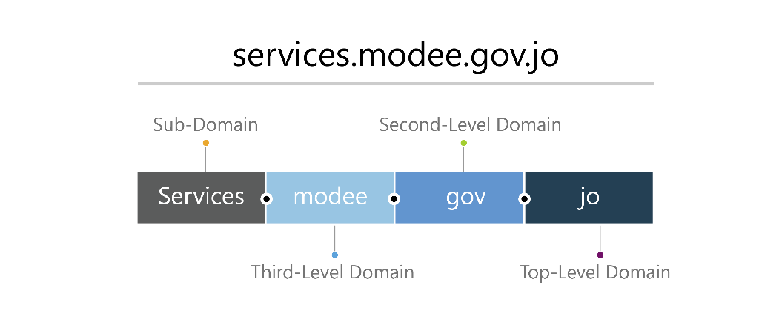

Figure
2

:
Domain Name Structure

Naming
Conventions

The government entities’ domains should support three types of naming conventions:
- Short English Naming Convention: The government entity should have a domain name that represents the entity’s abbreviation. For example: “www.modee.gov.jo”.
- Long English Naming Convention: The government entity should have a domain name that represents the entity’s complete name. For example: “www.digitaleconomy.gov.jo”.
- Arabic Naming Convention: The government entity should also have an Arabic domain name with hyphens separating words. For example:” الاقتصاد-الرقمي-و-الريادة. الأردن" .

Domain Binding and Access Protocols
- The domain name should be accessed using Secure Hypertext Transfer Protocol (https) with a valid certificate. For example:” https://modee.gov.jo “.
- Websites domain name should be accessed with or without “www” prefix. For example:
Website is accessible through both URLs “www.modee.gov.jo” and “modee.gov.jo”.

Directory Path and Page Names
- It is recommended that the website has a clear directory representing the current URL name. For example: “www.modee.gov.jo/news “.
- The page URL should be clear for both English and Arabic pages, where in Arabic the spaces should be replaced by (-). For example: in English
“www.modee.gov.jo/pages/aboutus”, in Arabic “www.mofee.gov.jo/pages/من-نحن “.
- URL can include file extensions as below: o .html, .php, .aspx, For example: “www.modee.gov.jo/pages/aboutus.html”,
“www.modee.gov.jo/pages/aboutus.php”, “ www,mode.gov.jo/pages/aboutus.aspx”.
Do
Clear path
www.modee.gov.jo/page/aboutus

Do
Clear path with file extensions www.modee.gov.jo/page/aboutus.aspx

Avoid
Unclear path www.modee.gov.jo/page/ viewpage? ID=2

Discoverability and Search Engine Optimization
Discoverability and Search Engine Optimization
Guideline ID: A.1.2
Development Lifecycle Stage:  ☒ Planning ☐ Design and Development | ☐ | Deployment | ☒ | Operation
Website Service Category
☒ Informative Website ☒ e-Services Website

Discoverability is the process of making the website and its content highly relevant for both search engines and searchers. It includes tasks that improve the performance and visibility of it and how search engines access the site, including indexing, crawling, schema, page speed, site structure and URL structure to make it easier for search engines to find and index a website by the appropriate keywords.
- Provide a proper Internal Linking for website pages by ensuring that each website page leads to where it is supposed to lead. Inner linking strengthens the overall searchoptimized value of a website.
- Provide XML sitemap and Logical Hierarchy: It offers search engine spiders easy access to web pages and provides visitors with directions for navigating the website.
- Provide SEO friendly URLs by considering the following:
  - Keep URLs simple: Avoid adding too many parameters. The search engines send out simplistic spiders/crawlers that may stop searching if they encounter any obstacles.
  - Links that are no longer working should be corrected or removed. Some of the search engines de-index websites if more than a certain number of links do not work properly.
  - Avoid changing the URLs structure and filenames once they are decided and set up.
- Unique, meaningful and relevant Meta Tags: Meta Tags of Metadata is the HTML markup tags that contain information about a web page. They are placed in the web page’s coding to help search engines understand the content of the page, the website should contain the following Meta Tags types:

Meta Tags | Description | Example
Description  Tags | These tags contain the description of the page being previewed; They should be as short and descriptive as possible. | <Meta name = “description” content = “this should be the dynamic unique description of the web page”>.
Title Tags | These tags describe the title of the website. | <title> your title here </title>
Keywords  Tags | These tags are a set of words that visitors will probably enter when looking for the website, they should be listed and separated by commas (,) | <Meta name = “Keywords” content =  “FOLLOW, INDEX”>
Table 1 - Meta Tags Types
- The website should have ALT values to all value adding graphical content; each ALT value should be short and meaningful.
- Through the website, each page description should be proper, short, and meaningful; explaining the page’s purpose and content.
- Website page title should be well-designed: o Headings that begin with ‘a’, ‘an’ and ‘the’ should be avoided. Keywords should be used first, as they will be recognized by search engines when ranking results. o Webpage content should be properly described using common keywords. o Page title should be brief, short, easy to read, and clear.
o Page title should be according to the website’s language (English/Arabic Titles).
- Strong social media presence should be provided; the entity’s website should be linked to its social media channels.
- Content should be strong and of high-quality. If people want to visit back the website, they should have a reason.
- Website should have a strong link building and backlinks strategy to achieve:
o More visibility of website pages in search results. o More traffic from other websites linked to the website (referral traffic). o Links can help in getting indexed faster in search results.

Cross Browsing and Screen Resolution
Cross Browsing and Screen Resolution
Guideline ID: A.1.3
Development Lifecycle Stage:  ☒ Planning ☒ Design and Development ☐ | Implementation | ☐ | Operation
Website Service Category
☒ Informative Website ☒ e-Services Website

Cross-browsing is to create web pages that are browser independent, so they can be accessed and viewed in the same layout regardless of the type of browser.
- The website is best viewed at 768×1366 screen resolution.
- Website should comply with the following browsers versions as a minimum:
Browser | Minimum Version to Support
Internet Explorer | 11.0 and above
Microsoft Edge | 40.0 and above
Firefox | 60.0 and above
Safari | 11.0 and above
Google Chrome | 70.0 and above
Opera | 57.0 and above
Table 2 - Accepted Browsers Versions

Make sure to mention a compatibility statement in the website footer that declares both browsers’ compatibility and best resolution.
For example: This site supports Microsoft Internet Explorer 11.0+, Firefox 3.0+, Safari 3.0+, Google Chrome 12.0. This site is best viewed at a screen resolution of 768 ×1366.

Access to Language
Access to Language
Guideline ID: A.1.4
Development Lifecycle Stage:  ☒ Planning ☒ Design and Development | ☐ | Implementation | ☒ | Operation
Website Service Category
☒ Informative Website ☒ e-Services Website

Arabic and English are the most used languages in Jordan. Therefore, all government websites should be bilingual (Arabic and English) at minimum.
- Arabic must be the default website language unless the website is meant to target nonArabic language site visitors or the majority of the website visitors and non-Arabic language site visitors.
- The change-language link should be located in the website header and consistent in all website pages as below:
  - Upper-left corner in Arabic version.
  - Upper-right corner in English version.
- The change-language link should be clear, using full words:
  - “English” to switch to the English version of the website. o "عربي" to switch to the Arabic version of the website.
Do
Full Words
English – عربي

Don’t
Abbreviations

EN – ع

-

Don’t

Flags

- The change-language link should always direct the site visitors to the same page in the selected language. If the content doesn’t exist in the selected language, site visitors should get a page mentioning that the content isn’t available in the selected language.
- For external links and downloadable files, it is preferred to have the site visitor browse files and links of the same language he is using. For example: If the visitor is browsing the English version of the website, all downloadable files should be in English.

Accessibility Actions
Accessibility Actions
Guideline ID: A.1.5
Development Lifecycle Stage:  ☐ Planning ☒ Design and Development | ☐ | Deployment |  | ☐ | Operation
Website Service Category
☒ Informative Website ☒ e-Services Website

Governmental websites should be developed with universal accessibility to allow the site to reach those who are trying to access the website regardless of their type or disabilities
(physical or visual), some of which are indicated below:
Disability | Description
Visual | Blindness, low vision or loss of visual acuity.
Auditory | Complete deafness or some levels of hearing loss.
Cognitive | Speech dysfunction, language or learning impairments.
Physical | Impaired mobility or loss of fine motor control.
Table 3 - Types of Disabilities
- The website should provide a clear accessibility bar that is consistent and accessible from any page in the website. The website accessibility bar should contain the following at minimum:
  - Text resize: The website text should be capable of being resized up to two-levels without losing content or functionality. Each level should decrease/increase font size between 1px up to 2px, as in the below figure “Figure 2: Font Resizing actions”.
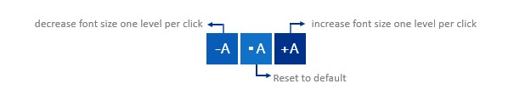

Figure
3

-

Font Resizing
A
ction
I
con
s

  - Color Blindness View: All website components including background, text, and images should change colors to black and white.
It is preferable to add Text-to-Speech functionality to provide an audio alternative for all textual and non-textual content.

  - Night Mood View: To make browsing experience at night more friendly for web visitors, the website should support displaying in low brightness.
- The website should be keyboard-friendly, providing the option of accessing major functionalities from the keyboard.
- The website should have a scroll-up button to reach the top of the page without scrolling upwards.

Enable Social Media
Enable Social Media
Guideline ID: A.1.6
Development Lifecycle Stage:  ☐ Planning ☒ Design and Development | ☐ | Implementation | ☐ | Operation
Website Service Category
☒ Informative Website ☒ e-Services Website

Social media channels and websites should work seamlessly to promote website accessibility.
Integrating the social website with the website can be managed through the following:
Social Media Buttons
- Having the social media buttons on the website is mandatory.
- The social media buttons should be consistently placed at the footer of the website pages, in addition to the “Contact Us “page.
- The social media buttons should be correctly linked to the entity’s account.
- Once the button is clicked, the entity’s account on social media should be opened in a new browser tab.
Sharing Buttons:
- Sharing buttons are meant to allow the site visitor to share the page’s content on his/her personal social media account, where sharing buttons are mandatory.
- Sharing buttons should be displayed on the top of each page, where in Arabic it should be shown on the left side of the page and in English on the right side of the page.
- Make sure to add the label “share “, “شارك" next to the buttons, to avoid the site visitors confusing the “Sharing Buttons“ with “Social Media Buttons“.

RSS Feeds Subscription
RSS Feed Subscription
Guideline ID: A.1.7
Development Lifecycle Stage:  ☐ Planning ☒ Design and Development | ☐ | Implementation | ☐ | Operation
Website Service Category
☒ Informative Website ☒ e-Services Website

RSS stands for Really Simple Syndication and it is a simple, standardized content distribution method that can help visitors stay up-to-date with the website content. It allows people to receive updates to web-based content of interest on visitors’ personal pages.
By subscribing, visitors start receiving new content automatically in the feed reader such as news, weather and stock quotes.
- Standard RSS icon should be visible and clickable, directing the visitor to the RSS page.
- RSS feed should be placed consistently beside the social media icons on the website homepage and accessible from all website pages.
- Government websites should have RSS feature for news as minimum.

Web Performance
Web Performance
Guideline ID: A.1.8
Development Lifecycle Stage:  ☐ Planning ☒ Design and Development | ☒ | Implementation | ☒ | Operation
Website Service Category
☒ Informative Website ☒ e-Services Website

As part of having the website well accessible by site visitors, it should be fast loading and well preforming, where website speed and performance are governed by multiple factors which include the application itself, hosting environment, network, connectivity, site visitor machine, etc.…
This standard document focuses on the minimum requirements from the website application’s side only. To reach the recommended web pages loading time, which is 9 seconds maximum, the website should have an ideal hosting environment and connectivity.
- The web page’s size shouldn’t exceed 5 MB.
- HTTP requests should be minimized, in addition to removing all unnecessary redirects and fixing all broken links.
- The time to first byte (TTFB) shouldn’t exceed 800ms, where TTFP is measured depending on HTTP request time, process request time, and response time.
- Reduce website images is a must; a single large image shouldn’t exceed 150KB, as for small images, they shouldn’t exceed 40KB.
- Minify and combine website files, including HTML, CSS, JavaScript and fonts.
- Using Asynchronous loading for page elements whenever it is possible. With asynchronous loading, files can load simultaneously. If a file is taking a while to load, other page elements will still load without any delay.
- Use defer JavaScript when it is possible, which means that the JavaScript is stopped from loading until other pages’ elements are loaded.
- Enable browser caching when it is possible.
- Hosting videos on external links like YouTube rather on the website.

Usab
i
lity and Design

Usability means to make sure that the site visitor will use the website to achieve specified goals with effectiveness, efficiency, and satisfaction in a specified context of use.

Site Navigation and Effective Sitemap
Site Navigation and Effective Sitemap
Guideline ID: U.2.1
Development Lifecycle Stage:  ☒ Planning ☒ Design and Development | ☐ | Deployment | ☒ | Operation
Website Service Category
☒ Informative Website ☒ e-Services Website

Navigation is the process that facilitates movement from one web page to another, it acts as the road map to all different areas and information contained within the website. When site navigation is designed properly, it helps visitors make sense of the information environment they are at.
When it comes to usability; ease-of-navigation should be a top priority. Following are the best practices for website navigation to significantly improve website user-experience:
- The website navigation structure should be from the visitor’s point of view.
- Navigation should be classic, simple, and predictable. Complex navigation tools should be avoided.
- The website should comply with the “Three Clicks Principle” that states that visitors should need at most three clicks from anywhere in the site to get to what they need.
- Site navigation should be simple enough for the site visitor to understand, but also contain the elements necessary to guide the visitor through the website.
- Navigation menus should be available on all pages within the website.
- Navigation menus should be organized in a meaningful, unambiguous way to display content to users.
- Visitor can reach all website information from navigation menus.
- Navigation menus should support transitional effects such as hover or mouseover effect. These effects are seen when mouse is over a certain element that makes it slide out, change color, or animate.
- Flash for navigation menus is forbidden.

Site Menus
Site menus are the most trusted and most used tool for the site visitors to access the website pages and information.
Main Menu: It is the collection of all main website pages grouped together targeting the main (major) audience of the website. Main menu can be viewed horizontally or vertically. It is highly recommended to have a horizontal main menu.
- The links in the main navigation should lead to pages within the site and behave in a very consistent way.
Don’t add links to external URLs in the main menu.

- The number of menu items should be limited to a maximum of nine, less is even better.
- Serial Position Effect: The most important items should be placed at the beginning and the end of the menu, as for the least important items, they should be placed in the middle. People's attention is highest for things that appear at the beginning and at the end.

Figure 4- Serial Position Effect in Arabic Website

Figure 5 - Serial Position Effect in English Website.
- Make sure to have the About Us at the beginning of the menu and Contact Us at the end of the menu.
- Menu items names should be short and familiar.
Do
Short and familiar menu item name
عن الوزارة

Don’t
Long menu item name

عن وزارة الاقتصاد الرقمي والريادة

- In the English version, each word should be capitalized. For example: “about us” should be
“About Us”.
- Submenus are not preferable; they are considered annoying to the site visitor.
- Navigation Labels should be easily recognized, such as “Home”, “About Us”, “Contact Us” etc. Creativity is not recommended in this practice.

Do
Easily Recognized Navigation Labels Home, Contact Us, الأخبار

Don’t
Creative but Not Easy Navigation Labels

Root, The Contacts, الوزارة في الصحافة

- Menu items should expand on click. Expanding the menu on mouse hover should be avoided.
Secondary Menu: It is a list of links that takes the site visitor to the website pages directly without grouping them. Secondary menu aims to provide links to secondary (minor) website audience such as vendors, job seekers, and entity employees.
- The number of menu items should be limited to a maximum of seven, less is even better. • In the English version, each word should be capitalized. For example: “tenders” should be
“Tenders”.
- Menu items names should be short and familiar.
- Menu items should have separators. For example, a dot or slash.
- Governmental secondary menu will include:
  - Site related information.
  - Information targeting secondary (minor) website audience.
At a minimum, containing the following links:
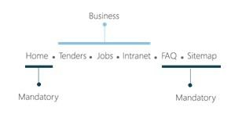

Figure
6

-

Secondary Menu Items

Page Side Menus
Pages Side Menu is the navigation menu that might change from one page to another. Its main objective is to show the website visitor additional pages he/she might be interested in.
For example: If a site visitor is browsing “About Us “page, the page side menu should contain “Organization Structure “, “The Minister”, etc.
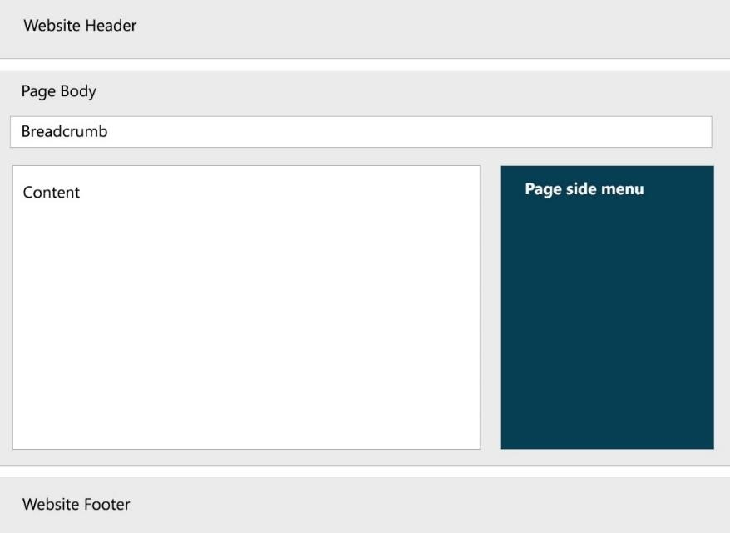

Figure
7

-

Page Side Menu

- Page side menu is preferable not mandatory.
- Page side menu should be placed vertically on the left in the Arabic version and on the right in the English version.

Breadcrumbs Bar
Breadcrumbs are meant to help the users keep track of their locations within the website.
- Breadcrumb should reach a maximum of five levels, reflecting the true hierarchy of the website, not the path users have chosen to arrive at their destinations.
- Breadcrumb should always start with a Homepage link.

Tab Navigation
Tab navigation is where the website navigation links appear as tabs, similar to the tabs used in a binder to divide the contents into sections. It can be used on both homepage and inner pages.
Tab navigation is a useful tool for having the content categorized. For example: It can be used on the homepage of the website to categorize the service section.
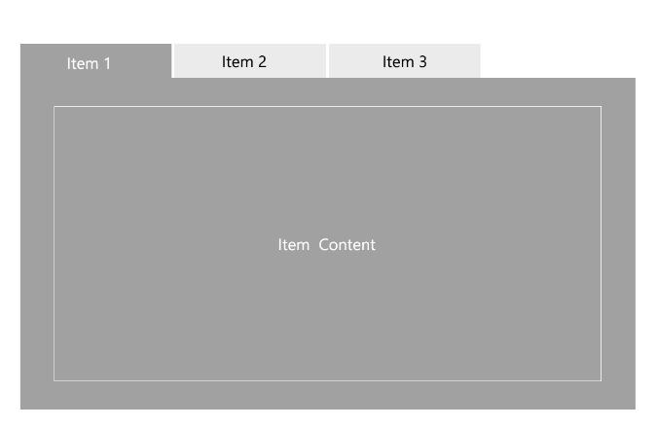 | 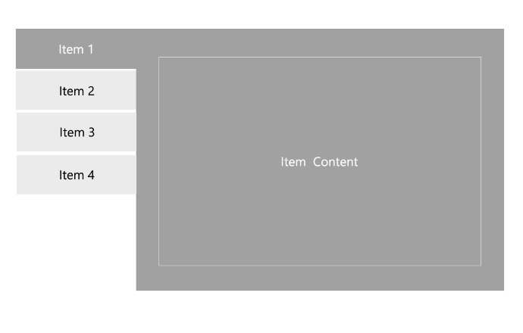
Figure 8 - Tab Navigation in English
- Tabs can be placed horizontally or vertically.
- Horizontal tabs should be ordered left-to-right in the English version, and right-to-left in the Arabic version.
- The number of tabs should not exceed five.
- Tab titles should be short and familiar.

Return to Homepage
Homepage is very essential for the visitors; for that, the websites should have a One-Click link to the homepage.
- The website logo should be clickable, directing the site visitor to the homepage.
- The secondary menu should contain a Home link.
- Breadcrumbs should always start with the homepage link.

Sitemap
Sitemap is a representation of the content on the website created to help both people and search engines. Sitemaps are crucial for a usable navigation system.
- Sitemap link should be available at a consistent location throughout the website.
- Sitemap link should be located in the secondary menu, which is considered as a mandatory item in the secondary menu.
- Sitemap should list down pages in a clear, hierarchical order; giving a plain overview of the website.
- Sitemap should be updated continuously.

Homepage
Homepage
Guideline ID: U.2.2
Development Lifecycle Stage:  ☒ Planning ☒ Design and Development | ☐ | Deployment | ☒ | Operation
Website Service Category
☒ Informative Website ☒ e-Services Website

The homepage is the main landing page of the website; it gives the site visitor the first and the most important impression about the website. The website homepage should be well designed and constructed.
- Homepage should clearly reflect the identity of the entity.
- The design and organization of elements on the homepage should be based on the users’ needs and expectations.
- Order the homepage sections vertically, according to the most important information. For example: Services should be the first section to appear after the introduction slider
“storyboard”.
- Each section can be divided horizontally, where the components in the same sections should be related. For example: News and announcements can be placed in the same
section.
- Avoid unnecessary decorations.
It is preferable to make some changes to the main page content at least once a week.

- The foreground and background colors should have a contrast ratio of at least 4.5:1 for normal text and 3:1 for large text.
- Contrast ratio should be of at least 3:1 for graphics and user interface components, such as form input borders.
To check the contrast ratio, visit https://webaim.org/resources/contractchecker/

- Below are the minimum main components of the homepage, where entities can add additional components based on their business and target visitors.
Section | Components | Importance
Header | Entity Logo: Should be placed in the upper right corner in the Arabic website and in the upper left corner in the English website, where the logo should be clear, readable, and not pixelated. | Mandatory
 | Accessibility Bar | Mandatory
 | Main Menu | Mandatory
 | Secondary Menu | Mandatory
Body | Introduction Slider (Storyboard): The storyboard is used for both decoration and information highlights. For example: New service provided by the entity, Important information, etc.  • Storyboard should have interesting graphics and headers. | Optional
 | Go to Action Banners. For example: Service, Contact Us, etc.. | Optional

 | Highlights Ticker is used for highlighting news or urgent announcement content on a periodical basis.  - Highlight ticker should include announcements or urgent information. For example: Tender announcements, national holiday announcements, job vacancies, new location, and important news.  - The text motion direction should be left to right in the Arabic version and right to left in the English version.  - It should have controlled text movement, allowing visitors to move it back and  forth.  - The text should pause on mouse hover.  If no announcements will be published, highlight ticker should be  avoided. | Optional
 | Services: The entity should clearly highlight its services on the website homepage based on the site visitors' needs and expectations.  - Services should be categorized based on the site visitor perspective such as investors, citizens, etc.; categorizing based on the organizational point of view should be avoided.  - Adding a “Trending Services “Section is preferable.  - It is preferable that each service in the section has a dedicated brief. | Mandatory  for entities that offer services
 | Core Business Information: The entity should highlight its core business information in the website homepage. For example: Financial websites should highlight the currency prices. | Optional
 | Entity News: The entity should highlight its news in the news section placed in the homepage with the following details:  - News title.  - News date.  - Image if existed. | Mandatory
 | Browse the Site: It is preferable to have browse the site section on the homepage to ease the access to important pages. | Optional
Footer | Website compatibility in terms of cross-browsing and ideal screen resolution, in addition to the application required to open the website’s file, for example: PDF reader. | Mandatory
 | Policies Statements:  - Privacy Policy.  - Terms of Use.  - Disclaimer.  - Copyright.  - Copyright Statement. | Mandatory
 | Headquarter Contact information:  - Phone Numbers  - Working Hours.  - Location.  - Fax.  - Directions | Mandatory
 | Government Shared Banners | Mandatory
 | Last Website Update Date | Mandatory
 | Social Media Buttons | Mandatory
Table 4 - Homepage Components.

Search Functionality
Search Functionality
Guideline ID: U.2.3
Development Lifecycle Stage:  ☐ Planning ☒ Design and Development | ☐ | Deployment | ☐ | Operation
Website Service Category
☒ Informative Website ☒ e-Services Website

A facility to search the content on the website is mandatory for all government websites. Providing a non-working search function is considered one of the most crucial flaws. The search feature should follow the guidelines below:

Search Box:
- The website should have an easy to reach search box located at the website header.
- Search box should be located in the homepage and all website pages at a consistent and visible location.
- The search facility can be presented by a search bar or a search icon that displays the search bar after clicking on it.
- Search function should be executed by clicking a button or pressing enter from keyboard, where both options should be available.
- Arabic special characters entered by the user in the search bar should be neglected.
For example: typing العربي and عربي should bring the same results.
- Search in English should be case insensitive.
Search Results:
- If no result is found, the site visitor should get the following messages: In Arabic “ لا يوجد نتائج متعلقة بكلمة البحث المدخلة” and in English “No Results found related to the entered search word”.
- Search results should appear in a new page.
- Page titles of the pages that contain the search result should be visible, in addition to a page brief.
- The total number of search results should be visible.
- Search results page should have a pager where the maximum number of results in each page shouldn’t exceed 15 results.

The Use of Icons - Iconography
The Use of Icons (Iconography)
Guideline ID: U.2.4
Development Lifecycle Stage:  ☐ Planning ☒ Design and Development | ☐ | Deployment | ☒ | Operation
Website Service Category
☒ Informative Website ☒ e-Services Website

Icons serve as an important visual aid in any graphical communication. Their primary function is to serve as a common visual language. Icons are the perfect way to support written content with visual cue while adding interest to website design. Clever use of iconography directs users to important content. When used correctly, icons can increase conversion rates and improve page stay times.
Support Icons: These icons are meant to support the website content in a graphical way, where the information icons do not replace the text. Support icons are used to:
- Draw attention to certain services, menus, or features.
- Enhance user experience on text-heavy pages: The use of small icons to represent each paragraph of content gives a clue as to what the content is about, allowing the users to scan the page and isolate information that is most relevant to us. It also makes this section of the page more visually interesting.
- Display large amount of content, and group multiple items into a unique interactive way. For example: Services categorization o Emphasize a Call to Action: Icons and the placement of arrows entice the visitor to click the call to action buttons.
Figure 9 - Trade Services Support Icons
• | Action Icons: These icons help users execute tasks easily and are familiar to users worldwide. The icon itself represents the content, eliminating the need to support the icon with any text. Clicking an action icon will perform the action the visitor has chosen.  Figure 10 - Action Icons

- Icons should be used with text-based content. Ideally, they should accurately represent the content, indicating a function, or information to a user.
  - Information Icons should have visible texts describing the icons’ meanings.
  - Action item should have Tooltips on mouse hover, mentioning the icon’s function. For example: When mouse hover is on YouTube icon, a label should appear with the word “YouTube”.
- Imprecise icons should be avoided, where conflict between the function and icon may confuse the user.
Do - Precise icon
Online Registration

Don’t - Imprecise icon
Online Registration

- Icons must follow a consistent style. For example: Commit round edges or sharp, light border or bold, black and white or colored icons.
For example: The image below demonstrates 5 sets of uniform icons.
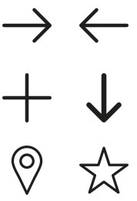

Figure
11

-

Icons
S
ets

- Excessive use of icons should be avoided, they support graphics and should not be used to represent every piece of information on the site. Summarizing information into succinct manner paragraphs, when pairing it with real life photography, is better.
- Unnecessary creativity in selecting icons should be avoided. Icons should be classic.
Do - Classic, Simple Icon

Don’t - Complicated Icon

- Applying icon hover effect when mouse over the icon is preferable. Icon hover effect should be simple. Effects that contain motions like icon shake or flip should be avoided.
- Suitable Icons Formats:
  - Scalable Vector Graphics (SVG), Portable Network Graphic (PNG). o Font Awesome is preferable. For more information visit: www.fontawesome.com.

Images for Web
Images for Web
Guideline ID: U.2.5
Development Lifecycle Stage:  ☐ Planning ☒ Design and Development | ☐ | Deployment | ☒ | Operation
Website Service Category
☒ Informative Website ☒ e-Services Website

Images on the website act as storytellers, allowing site visitors to visualize the content. In addition, it gives the visitor the pleasant experience when browsing the website. Based on the images’ objective, website images can be categorized as below:
• | Design images: Where images are used for decoration purposes to enhance the design and website layout. For example: Website background images, pages header images, etc. Removing the Design Images from the website will not affect the website functionality or reduce the site visitors’ understanding of the content.
• | Content Images: Images are the content or a part from it. For example: News images, photo gallery, ad banner, etc..., where content images can’t be eliminated from the website. Images can consist of photographs, infographics, cartoons, GIFs or other visual elements.

- Use ALT values, where Alt tag is a text alternative to an image; it is meant to give an image a description when it didn’t load well. Moreover, it supports the image to appear in the search engines search results. Alt tag in HTML is like: < img src="..." alt="describe your image">.
- All images used on the website for both design and content should be either copyrighted to the government entity itself or free to use.
- Compress all image files to reduce memory usage and speed the page loading time, where:
  - Images displayed at full width (Images that span the width of the page) should be optimized to 150KB at maximum.
  - Images in the content should be optimized to 40KB at maximum.
- Low-resolution images should not be uploaded, and images should not be pixelated.
- Stretching or shrinking images should be avoided. All images should be displayed in their original dimensions’ ratio.

Web Forms
Web Forms
Guideline ID: U.2.6
Development Lifecycle Stage:  ☐ Planning ☒ Design and Development | ☐ | Deployment | ☐ | Operation
Website Service Category
☒ Informative Website ☒ e-Services Website

A web form is a medium that allows the site visitors to get in contact and to submit information or utilize available online services (through desktop or mobile websites), which in turn should be processed. It is important that online forms available on the website are userfriendly, easy to use, and simple. Below are guidelines for building forms:
Form Introduction:
- Web forms pages should have a good title and a brief description about the form’s purpose.
- It is preferable to mention the approximated time needed to finish filling the form.
- Any pre-request documents or processes to complete the form should be clearly defined to the site visitor before starting.
Form and Fields:
- The form should be kept simple; only the real needed information is asked for.
- The form should be keyboard-friendly, allowing visitors to move through it using the keyboard.
- Stick to logical sequencing for the fields; follow a standard sequence for both fields and value choices. For example: Credit-card number, Expiration date, Security code for fields and a drop-down list of nationality in non-criminal service should start with Jordanian for value choices.
- All fields that are mandatory should be clearly labeled or marked in a way that indicates that these fields are required. (*) symbol is commonly used as a mandatory label.
- Required fields should be minimum.
- Give examples and tips for fields that might not be clear to the site visitor. For example: In credit card data form, give the site visitor a hint where he can find CVV code.
- Default values should be displayed wherever possible. This could be the last item selected by the site visitor or in some cases, the most frequently selected item. For example:
Today’s date for some date entry fields.
- Selectable pre-defined inputs should be provided where possible to minimize manual data entry. For example: Drop down list and radio buttons.
- For any required numerical data, the type or unit should be clearly mentioned. For example: JOD, Meters, etc.
- If the site visitor is required to enter phone number, passport number, identity card or credit card information, the format should be given with examples. For example: Phone number 07XXXXXXXX.
- Wherever a specific data format is required, the format should be stated within or adjacent to the field with an example. For example, DD-MM-YY or DD/MM/YYYY. Having a calendar is optional.
- Fields that require attachments should indicate the following:
  - The maximum acceptable size.
  - The acceptable formats for attachments.
Submission:
- Captcha is a must, where no form can be submitted before it passes captcha.
- Submission and cancelation buttons should be clear.
Do

Primary action buttons obvious, while secondary action buttons noticeable but not as
prominent
.

Cancel

Sign up

Don’t
Emphasizing the cancel button with attractive colors.
Sign Up Cancel

In Arabic forms, submission button is on the right where in English forms, submission

button is on the left
.

Cancel

Sign
U
p

تسجيل

الغاء

- Upon submitting the form, the site visitor should get a confirmation message to notify the visitor that the form is successfully submitted, and based on the forms business, the below messages and functions are also applicable:
  - Reference number for follow up purposes if case needed. o Email or/and SMS should be sent to site visitors with details. o Notification on the duration needed to complete the request should be provided.
  - A facility to print the confirmation screen for future reference and use should be provided.
- It is preferable that the website redirects the visitor to the homepage after the form is submitted to avoid confusions.

Animation
Animation
Guideline ID: U.2.7
Development Lifecycle Stage:  ☐ Planning ☒ Design and Development | ☐ | Deployment | ☒ | Operation
Website Service Category
☒ Informative Website ☒ e-Services Website

Website animation is an added value for both the design and content, below are guidelines for using animations:
- Animation should be flash free; JavaScript and CSS coding should be used to add moving elements to the site without overloading it.
- Animation should be simple; complicated animation that may overload the website and distract the user should be avoided.
- Animating several elements at once should be avoided in order not to distract the user with too much going on.
- Animation should be meaningful; random animation with no purpose should be avoided.
- All animated items should move consistently; items with random direction should be avoided.
- Duration and speed of the animation should be slow enough to give users the possibility to notice the change, but at the same time quick enough not to cause waiting.
- The animation motion should be according to the visitors’ reading direction. For example: The news ticker movement in Arabic should be from left to right, and in English from right
to left.
- The use of animation should be limited; animation is usually distracting and often irritating to users of the website.

Web Design
Web Design
Guideline ID: U.2.8
Development Lifecycle Stage:  ☐ Planning ☒ Design and Development | ☐ | Deployment | ☐ | Operation
Website Service Category
☒ Informative Website ☒ e-Services Website

A website should be well designed and constructed to provide a good impression for the site visitor. It must clearly reflect the identity of the entity and structure for the site visitor.
As a governmental entity, following the Jordan Government Website Design Kit (GWDK) is a must, whereby the GWDK contains a ready to use template and components.
To download the Jordan Government Website Design Kit (GWDK), visit www.modee.gov.jo

Content and Site
Architecture

Sitemap

Sitemap
Guideline ID: C.3.1
Development Lifecycle Stage:  ☒ Planning ☒ Design and Development | ☐ | Deployment | ☐ | Operation
Website Service Category
☒ Informative Website ☒ e-Services Website

A well-organized sitemap is a blueprint for a successful website, but only if it starts with a solid information architecture (IA). It is essential to understand the users’ needs in order to create a website that serves them.
The following are typical questions, which can assist in customizing the site for the respective visitors:
- Who are the target audience(s) of the website?
- Does your website address their needs?
- What do you want the visitors to know, think, or do when they visit the site or after they have left it?
The government website should contain the below pages as minimum, only if applicable:
Page Name- English | Page Name –Arabic
About Us | عن <الجهة>
Welcome Message | الكلمة الترحيبية
Organization Structure | الهيكل التنظيمي
Directorates | المديريات
Ministers | الوزراء
General Secretaries | الأمناء العامون
Service Guide | دليل الخدمات
e-Services | الخدمات الإلكترونية
Forms Guide | دليل النماذج
Entity News | الأخبار
Annual Reports | التقارير السنوية
Contact Us | اتصل بنا
Useful Links | روابط مفيدة
FAQ | أسئلة متكررة
Sitemap | خريطة الموقع
Table 5 - Government Website Minimum Content
Template of sitemap can be found below:
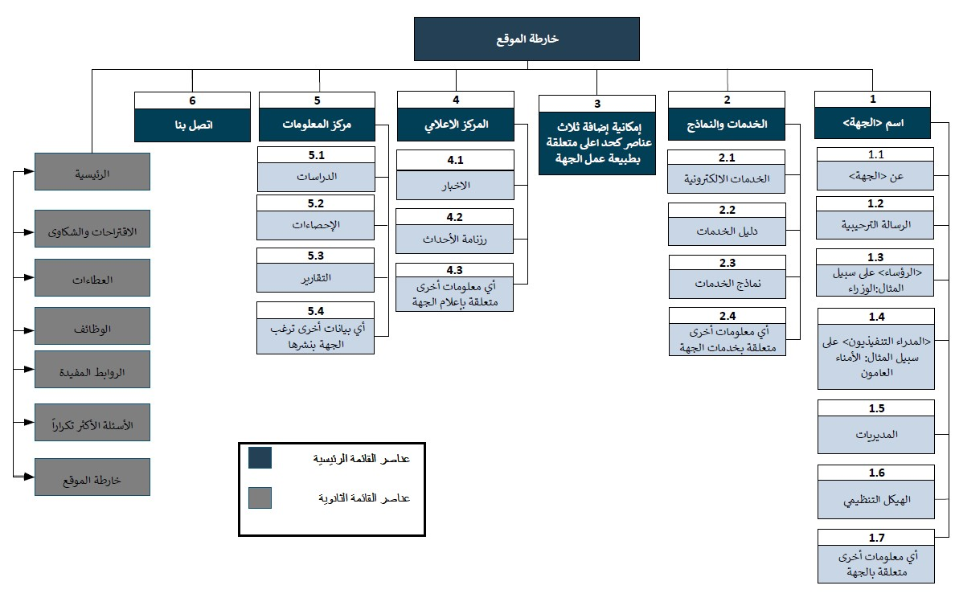
Sitemap
–

Arabic Template

Figure
12

-

Sitemap Arabic
V
ersion

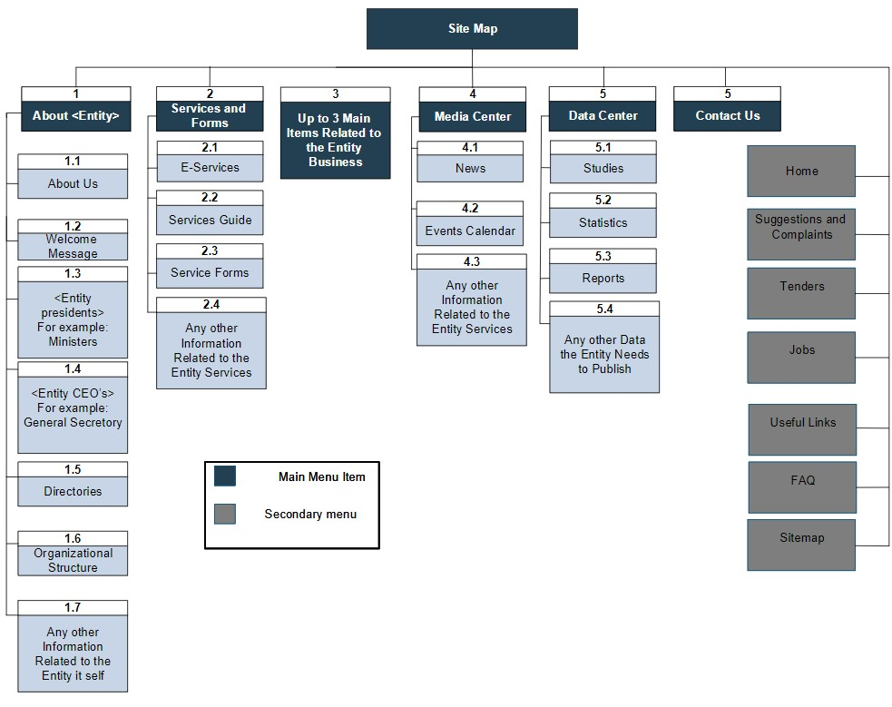
Sitemap
–

English Template

Figure
13

-

Sitemap
English

V
ersion

Site Pages
Site Pages
Guideline ID: C.3.2
Development Lifecycle Stage:  ☒ Planning ☐ Design and Development | ☐ | Deployment | ☒ | Operation
Website Service Category
☒ Informative Website ☒ e-Services Website

The way website content is categorized and presented is vital to enhance the user experience. Due to that, every website should have its content categorized for the specific targeted audience, and information should be organized reflecting the business processes from the visitor perspective. There should be clear delineation in web-content between:
- Content for individuals.
- Content for businesses.
- Content for the public sector.

Informative Site Pages
Reading content from a screen is totally different than reading printed documents. The website readers usually scan; they don’t read the same way as reading a book. Due to that the content should be written in a simple and precise way, in addition to writing brief sentences, and clear headings with information distributed across the screen.
• | 79 % of test site visitors always scanned any new page they came across.
• | 16 % read word-by-word.
• | Reading from computer screens is 25% slower than reading from papers.
• | Web content should have 50% of the word count of its paper equivalent.

Informative page should consist of page title, headings, headlines, and content, as below:
Title  Heading  Cont | عن الوزارة
 | وزارة الاتصالات وتكنولوجيا المعلومات
 | Headline |  | نشأة ومسؤوليات الوزارة
 | ent | تولت وزارة الاتصالات وتكنولوجيا المعلومات، ومنذ إنشائها في نيسان عام 2002، مسؤولية وضع السياسات  والتشريعات الخاصة بقطاعات الاتصالات وتكنولوجيا المعلومات والبريد في المملكة الأردنية الهاشمية وذلك وفق ا للمهام والمسؤوليات المحددة ضمن قانون الاتصالات رقم 13 لسنة 1995 وتعديلاته وقانون الخدمات البريدية رقم 34 لسنة  . 2007
Headline |  |  | تمكين بيئة الاستثمار في قطاع المعلومات
Content | عملت الوازرة مع الجهات المعنية على مراجعة التشريعات الخاصة بتسهيل تأسيس الشركات ومنح قطاع تكنولوجيا المعلومات إعفاءات من الضرائب والجمارك ومتابعة جميع التحديات التي تواجه قطاع الاتصالات وتكنولوجيا المعلومات وريادي الإعمال
Content | في هذا القطاع .
 | Headline |  |  | برنامج الحكومة الإلكترونية
 |  | برنامج الحكومة الإلكترونية وهو برنامج وطني تم اطلاقه بتوجيهات من قبل صاحب الجلالة الملك عبد الله الثاني ،يهدف إلى المساهمة في تحسين أداء الحكومة التقليدي في مجال تقديم الخدمات وزيادة كفاءتها ودقتها واختصار الوقت لأداء الأعمال ورفع مستوى رضى المواطنين والمتعاملين مع الحكومة وخلق التكامل بين الإدارات الحكومية .
Figure 14 - About Us Example

Page Title: Page title is what describes the web page content for visitors.
- Page titles must properly describe the webpage content, in comprehensive and brief words. For example: About Us, Contact Us, Organization Structure, etc.
- Page title should be equal to tab title, knowing that tab title should be formatted “Page Title – Website name“. For example, About Us- Ministry of Digital Economy and
عن الوزارة – وزارة الاقتصاد الرقمي والريادة.Entrepreneurship,

Don’t
Substring Page title.
عن....

Heading: The heading should be a meaningful sentence that describes the overall page content.
- Each page should include only one heading.
- Heading should be a short sentence not exceeding 10 words.
Headline: Headline is the meaningful sentence that describes a specific part of the page.
- Headlines should be added in content to describe the upcoming part of the content.
- In English, headlines should be in title case format, where the first letter of each word is capitalized, except the coordinating conjunctions (and, but, or, nor, for, etc.) and prepositions of four or fewer letters (with, to, at, and so on).
Content: This part describes the main point of the article in details.
- It is preferable to start with a conclusion even if it is just a short line.
- The content shouldn’t be crowded, studies concluded that site visitors enjoy page whiteness.
- Paragraph line spaces should be between 1.5px to 3.0px depending on the website font type.
- Spacing between different paragraphs should be between 3px to 5px depending on the website font type.
- Text alignment should be from “left to right” for English content and from right to left for
Arabic content.
- Text Justification should be avoided.
Italic and underline text should be avoided.

- Information should be presented from a third-party. For example: Instead of saying “We will manage the process”, say “The Ministry of Digital Economy will manage the process”.
- Images and icons can be used to simplify text complexity.
- Detailed information should be hyperlinked and moved to secondary pages to simplify the page look.
- The content should be free of spelling and grammar mistakes.
- Use consistent style in page content in both formatting and context.
- The date format used in the website should be: dd/mm/yyyy.
- Content should be present, accurate, and up to-date.
- Content of the website should be logically organized and predictable.
- Printer-friendly version is a must, which prints content formatted correctly on the hardcopy with page numbers and clear presentation.
Visitors should be able to rate any content throughout the website using the five-star

rating system.

If the content contains external links, they should be opened in a new tab.

List
A list page is the page that provides meaningful grouping for data and information, where the data might be downloadable files, URLs, and Informative Site pages. For example: List of news, list of services, list of annual reports.
Search and Filtration:
- Search functionality should be added if the number of list items exceeds 20 items.
- Search can be by name, date, type ... etc.
- Search in Arabic should neglect special letters.
- Search in English should be case insensitive.
- Search to list items should be by name, date … etc., depending on the list content.
- If the data structure requires adding categories to list items, it should be added according to the website visitor’s point of view. For example: Categorize in terms of visitors’ types.
Don’t categorize in terms of service location.
- If the data structure requires adding sub-categories to list items, the default value should be “View All“.
List Items:
- The list titles should be clear.
- Item title shouldn’t exceed 70 characters.
- Items should be clickable if they are linked.
- Titles shouldn’t be sub-stringed, show the whole written title.
- It is preferable to have a brief under the list title.
- Links to item details should be clear using the term (view or read more).
- If the item is a downloadable file, document type and size should be mentioned.
- List items should be sorted according to specific order based on its content. For example:
priority, date, alphabetical, etc.

Services Guide
Services is one of the main interests for the website visitors. The Service Guide objective is to provide a data repository for all services provided by the entity.
Categorization: Service should be categorized from the site visitor point of view. For example: Categorize in terms of service type. Don’t categorize in terms of department that provides the service.
Search:
- Search functionality should be added if number of services exceeds 10 items.
- Search by name should be added.
- Search in Arabic should neglect special letters.
- Search in English should be case insensitive.
- Search for list items should be by name, date … etc., based on the services’ business.
- If the data structure for the services requires adding categories, it should be added according to the visitor’s point of view.
- If the data structure requires adding sub-categories to the services, the default value should be “View All “.
Service Card: The Service card should contain the below information as minimum:
- Name: The name of the service should be self-explanatory.
- Description: Brief description about the service; by reading this brief, the site visitor should know if this service is the one needed.
- Requirements: The requirements that the site visitor need to provide in order to get served. For example: Identity documents, ownership papers, etc.
- Procedures: List of steps indicating the service process; steps description should be clear and sequenced.
- Needed Forms: If services require submitting forms, this item should provide access in a download PDF file option.
- Expected Completion Time: This item should provide the expected average time to complete the service.
- Fees: Fees of the service should be available covering all cases when different fees might be required depending on certain conditions.
- Centers: Physical locations that provide the service.
- E-service Option: If the service is available online, the page should display a “get it online” option.

Branches Guide
For governmental entities that have branches, each entity should provide the site visitors with helpful information on each branch, such as location and contact details. Such information about the branches should be available on the website to accommodate the customer’s needs and expectations.
Categorization and Search:
- Enable search by branch name if applicable.
- Add categorization based on location.
Results:
- The search results should display each branch name, city, and service region.
- Clicking on a certain item should lead the visitor to the branch card page that provides:
  - Name.
  - Location: Location description with map URL.
  - Services Provided. o Contact Information.
  - Working Hours. o Branch Service Region.

Downloadable Files
Downloadable Files
Guideline ID: C.3.3
Development Lifecycle Stage:  ☐ Planning ☐ Design and Development | ☐ | Deployment | ☒ | Operation
Website Service Category
☒ Informative Website ☒ e-Services Website

Governmental entities websites should offer download links for files in order to provide the complete information to the visitors and satisfy their needs.
- The file name should be understandable and clear.
- The file formation must be mentioned. For example: PFD, Word, Excel.
- File size should be mentioned, where files should be optimized to be minimum.
- Downloadable file URL should have its words separated with underscores instead of spaces.
- The phrase “download” “تحميل“should be clear and placed properly.
- It is preferable to avoid having files, which require purchasing licensed software. For example: MS Word, MS Excel, MS PowerPoint.
- Files Reader Applications should be available on the website’s footer.

Contact Information
Contact Information
Guideline ID: C.3.4
Development Lifecycle Stage:  ☒ Planning ☐ Design and Development | ☐ | Deployment | ☒ | Operation
Website Service Category
☒ Informative Website ☒ e-Services Website

A website should provide full contact details for the government entity, in case the customer wants to get in contact with the entity. Several types of contact information should be available on the website to accommodate the customer’s needs and expectations.
Headquarter Contact Information:
- Phone Numbers; make sure to follow 00962-X-XXXXXXX.
- Fax Numbers; make sure to follow 00962-X-XXXXXXX.
- P.O. Box Address.
- Contact Email.
- Location Description.
Location Map
- Location should be well pinned on Google Maps.
Use Google Maps. Don’t use images for the location.

Contact Us form
- The contact us form should include the blow filed as minimum:
  - Type (optional), it should be dropdown list contains all possibility based on the entity business. For example, Suggestion, complaint, information request, etc.
  - Subject.
  - Name.
  - Phone number. o Email.
  - Details.
- A confirmation message should be viewed when a form is submitted.
National Call Center Numbers: National call center numbers must be mentioned in the contact us page.
Branches Directory: The branches directory page should be linked to the contact us page.
Working Hours: Working hours must be mentioned in the contact us page.
Social Media Channel: Social media channels must be listed in the contact us page.

Cross Government Information
Cross Government Information
Guideline ID: C.3.5
Development Lifecycle Stage:  ☐ Planning ☐ Design and Development | ☐ | Deployment | ☒ | Operation
Website Service Category
☒ Informative Website ☒ e-Services Website

The cross-government information is content that all government entities should have in their website. Once this document is released, all government entities should have the below information on their websites.
Information | Description
Amman Message Website | Place Amman Message Logo at the website footer.  Redirect the users to www.ammanmessage.com
Human Rights National Plan | Have the plan as a PDF document accessible from the website footer.
The Right to Obtain  Information Form | The form must be placed on the website.
مدونة السلوك الوظيفي | Have the PDF document accessible from the website footer.
حكومتي بخدمتي  بوابة الحكومة الالكترونية | Place the Logo at the website footer.  Redirect the users to https://jordan.gov.jo
بخدمتكم | Place the Logo at the website footer.  Redirect the users to https://jordan.gov.jo/wps/portal/Home/CMU?lang=ar
Table 6- Cross Government Information

FAQ
FAQ
Guideline ID: C.3.6
Development Lifecycle Stage:  ☒ Planning ☒ Design and Development | ☐ | Deployment | ☒ | Operation
Website Service Category
☒ Informative Website ☒ e-Services Website

FAQ is an abbreviation for “Frequently Asked Questions”. It refers to a website page that provides answers to a list of typical questions that users might ask regarding a particular subject.
- FAQ link should be available at the secondary menu in a consistent location.
- The question should be clear. It is preferable to use short questions.
- Website can provide FAQ listed in categories. For example: Digital transformation questions, entrepreneurship.
- A facility to ask a new question should be available in case the user’s request is not
fulfilled.

Website Policies
Website Policies
Guideline ID: C.3.7
Development Lifecycle Stage:  ☐ Planning ☐ Design and Development | ☐ | Deployment | ☒ | Operation
Website Service Category
☒ Informative Website ☒ e-Services Website

Government entities should place their Policies Information on the website in the footer section throughout all website pages.

Privacy Policy
- Privacy Policy should be linked in the website footer.
- Below is a Privacy Policy template in both Arabic and English.
Privacy Policy – Arabic Template
سياسة الخصوصية
لا تقوم "اسم الجهة" والموقع الإلكتروني الخاص بها بجمع معلومات شخصية عن زوار الموقع الإلكتروني إلا
إذا اختار زائر الموقع مشاركة هذه المعلومات.
إن معلومات التصفح على سبيل المثال ولا الحصر مثل أوقات الزيارة وزيارة الصفحات وبلد الزيارة لا تعتبر
معلومات شخصية ويحق لـ “اسم الجهة" استخدام هذه المعلومات لغايات تقييم استخدام الموقع
وتحسينها. وباستخدام هذا الموقع الإلكتروني، فإنك توافق على شروط سياسة الخصوصية هذه.
يتم التعامل مع جميع البيانات المزودة للموقع بخصوصية تامة، ولا يتم مشاركتها إلا الأفراد والجهات
المصرح لهم فقط لغايات تقديم الخدمات وإجراء الإحصائيات والدراسات والمسوحات، ولن يتم مشاطرة
و/أو بيع و/أو نقل هذه المعلومات إلى أي طرف ثالث بدون موافقة زوار الموقع المسبقة.
يحتوي هذا الموقع على روابط لمواقع خارجية، وعليه فإن “اسم الجهة" تخلي مسؤوليتها عن ممارسات
خصوصية خارجة عن موقعها الإلكتروني.
تحتفظ "اسم الجهة" بحق إجراء أي تغيير على سياسة الخصوصية دون تقديم أي اشعار مسبق، وباستمرار
استخدام الزائر للموقع الإلكتروني، فإنه زائر قد قبل ووافق على هذه التغييرات وما يترتب عليها.
تكون قوانين المملكة الأردنية الهاشمية وحدها هي القوانين واجبة التطبيق في كل ما يتعلق بالن زاعات التي
تنشأ من جراء استخدام هذا الموقع الإلكتروني، كما تختص محاكم المملكة الأردنية الهاشمية حصري ا بالنظر
في تلك النزاعات والبت فيها.

Privacy Policy – English Template
Privacy Policy
"Entity Name" and its website shall doesn’t collect personal information about the visitors of the website unless the visitor selects to share this information.
Browser information, including but not limited to visit duration, page visits, and country of visit are not considered personal information. “Entity Name” may use this information for the purpose of evaluating and improving the use of the website. By using this website, you agree to the terms of this Privacy Policy.
All data provided to the website shall be strictly confidential and shall only be shared by authorized individuals and entities for the purpose of providing services, and conducting statistics, studies and surveys. This information shall not be shared, sold and/or transmitted to any third party without the prior consent of the visitors of the website.
This website contains links to external websites and therefore “Entity Name” disclaims responsibility for privacy practices outside its website.
“Entity Name” reserves the right to make any changes to the Privacy Policy without giving any prior notice. As the visitor continues to use the website, he/she has accepted and agreed to these changes and their consequences.
Only the laws of the Hashemite Kingdom of Jordan shall be applicable in all matters relating to disputes arising from the use of this website. The courts of the Hashemite
Kingdom of Jordan shall have exclusive jurisdiction to investigate and decide on such disputes.

Copyrights
- Copyrights should be linked in the website footer.
- Below is a Copyrights template in both Arabic and English.
Copyrights – Arabic Template
حقوق النسخ والنشر
تعتبر جميع محتويات الموقع الإلكتروني على سبيل المثال لا الحصر )النصوص والرسومات والصور
والملفات والروابط وملفات الصوت ملكا لـ )اسم الجهة( ومحمية بموجب قانون حماية حق المؤلف في
الأردن رقم 22 لعام 1992 وتعديلاته وبموجب الاتفاقيات الدولية.
يسمح )اسم الجهة( للغير القيام بما يلي:-
- تنزيل و/أو الإطلاع و/أو الطباعة لأي معلومات منشورة للاستخدام الشخصي أو للاستخدام داخل المؤسسة ولأغراض غير تجارية.
- وضع روابط على موقعهم تؤشر على أماكن وجود المعلومات على الموقع.
- إعادة نشر أجزاء بسيطة من المعلومات شرط أن يتم النشر دون التعديل وبالشكل الأصلي له مع ضرورة الإشارة بشكل واضح إلى مصدر هذه المعلومات" اسم الجهة".
في حالة وجود حاجة للاستخدام لغير الغايات الموضحة أعلاه، يرجى مخاطبة "الجهة" من خلال العنوان
الوارد أدناه، مع مراعاة ضرورة تحديد المعلومات المطلوبة وتوضيح الهدف من الاستخدام.
"عنوان الجهة"

Copyrights – English template
Copyrights
All contents of the website, including but not limited to texts, graphics, images, files, links, and audio files are the property of (Entity Name) and are protected by the Copyright
Protection Law of Jordan No. 22 of 1992 and its Amendments, and by international agreements.
(Entity name) allows third parties to:
- Download, access, and/or print any information published for personal or in-house use and for non-commercial purposes.
- Place links on their website indicating the location of the information on the website.
- Republish minor parts of the information, provided that the publication is done without modification and in the original form, with the need to clearly indicate the source of this information “Entity Name".
If there is a need for use other than the above objectives, please address the "Entity" through the address below, considering the need to specify the required information and clarify the purpose of use.
"Entity Address

Copyrights Statement
- Copyrights Statement should be mentioned in the website footer.
- Below is the Copyrights Statement template in both Arabic and English.
Copyrights Statement – Arabic template
جميع الحقوق محفوظة © < السنة الحالية> . <اسم الجهة>

Copyrights Statement – English template
All Rights Reserved © < Current Year >. <Entity Name>.

Terms of Use
- Terms of Use should be linked in the website footer.
- Below is a Terms of Use template in both Arabic and English.
Terms of Use – Arabic template
شروط الاستخدام
تنطبق قواعد استخدام الموقع الإلكتروني على جميع الزوار .ويحق لـ "الجهة" إيقاف و/أو منع و/أو إنهاء
استخدام الموقع عن أحد المستخدمين في حال حدوث انتهاك من قبله لتلك القواعد ،أو في حال توفرت
أسباب تدعو للاعتقاد بأن أحد المستخدمين قد انتهك وخالف شروط وقواعد الاستخدام.
ويُحظر على زوار الموقع انتهاك أو محاولة انتهاك الإجراءات والقواعد المعمول بها لحماية الموقع، ويشمل
ذلك على سبيل المثال لا الحصر الأعمال التالية:
- الوصول إلى البيانات التي لا يقصد تقديمها لهذا المستخدم، أو الدخول على خادم أو حساب لا يصرح للمستخدم بالدخول إليه.
- محاولة إجراء اختبار أو مسح أو فحص لإمكانية إصابة نقاط الضعف في نظام أو شبكة البوابة، أو انتهاك سلامة الإجراءات أو توثيقها دون تصريح رسمي منها.
- محاولة التدخل في الخدمة المقدمة لأي مستخدم، أو مستضيف، أو شبكة، بما في ذلك على سبيل المثال وليس الحصر، عن طريق وضع فيروس على الموقع، أو زيادة الحمل عليه، أو إرسال رسائل دعائية إليه، أو إغراقه بالرسائل الإلكترونية، أو محاولة تعطيله.

إن مخالفة قواعد الاستخدام وانتهاك النظام أو الشبكة، يعرض المخالف للمسؤولية المدنية والجنائية. وسيتم
مباشرة التحقيق في الحالات التي قد تنطوي على مثل هذه المخالفات والانتهاكات وملاحقة المتسبب فيها
قضائي ا .
إن " الجهة " غير مسؤولة عن أي تأخير أو تردي في جودة الخدمة أو سوء أداء أو انقطاع في الخدمة لأي سبب كان، ويسقط المستخدم أي مطالبة له ضد "الجهة" بهذا الخصوص.

Terms of Use – English Template
Terms of Use
The Terms of Use of the website shall apply to all visitors. The “Entity” reserves the right to suspend, prevent, and/or terminate the use of the website by any user in the case of any violation of these terms, or in case there are good reasons to believe that a user has violated the Terms and Conditions.
Visitors to the website shall not violate or attempt to violate the applicable procedures and regulations for protecting the website, which includes, but are not limited to:
- Accessing data not intended for the user or logging into a server or an account which the user is not authorized to access.
- Attempting to test, scan or probe the vulnerability of the system or network or to breach security or authentication measures without proper authorization.
- Attempting to interfere with the services provided to any user, host or network, including but not limited to submitting a virus to the website, overloading,
"flooding", "mail-bombing" or "crashing" the website.
Violation of these Terms of Use and breaching the system or network may result in civil or criminal liability. Occurrences of such violations and breaches shall be investigated, and users who are involved in such violations may be legally prosecuted.
The "Entity" shall not be responsible for any delay, poor quality of service, or poor performance or interruption of the service for any reason, and the user shall drop any claim against the "Entity" in this regard.

Disclaimer
- Disclaimer should be linked in the website footer.
- Below is a Disclaimer template in both Arabic and English.
Disclaimer – Arabic template
إخلاء المسؤولية
على الرغم من قيام " الجهة " ببذل الجهد اللازم لمراعاة دقة المعلومات المنشورة وسرعة تحديثها على
الموقع الإلكتروني، إلا انه لا يضمن ولا يتحمل أي مساءلة قانونية تعتمد على دقة و/أو شمولية و/أو شكل
المعلومات المنشورة ولا يتحمل أي تبعات لأي خسائر ناتجة عن الاعتماد على هذه المعلومات.
بالرغم من أن " الجهة " يبذل الجهد اللازم لاستمرار عمل موقعه على شبكة الانترنت ، إلا أنه قد يحصل في
بعض الأحيان انقطاع و/أو بطئ لخدمات الموقع لأسباب خارجة عن إرادة " الجهة"، وفي هذه الحالة فان "
الجهة" لا يتحمل أي مساءلة قانونيه و/أو خسائر ناتجة عن ذلك.
إن الروابط الموجودة على الموقع والتي تنقل المستخدم إلى مواقع أخرى غير مشمولة بهذه السياسة ولا
يتحمل " الجهة" أي مسؤولية قانونية ناتجة عن الانتقال إلى هذه المواقع.

Disclaimer – English Template
Disclaimer
Although the entity makes the necessary efforts to take into account the accuracy of the published information and the speed of updating it on the website, it shall not guarantee, shall not assume any legal liability based on the accuracy, comprehensiveness, and/or form of the published information, and shall not bear any consequences for any losses resulting from the dependency on this information.
Although the “Entity” makes the necessary effort to maintain the operation of its website, there may be occasional interruptions and/or slowness of the services of the website for reasons beyond the control of the “Entity”, in this case, the "Entity" shall not assume any legal liabilities and/or consequential losses.
Links on the website that redirect users to other sites are not included in this Policy, and the "Entity" shall not assume any legal liability resulting from the redirection to these websites.

Content Management System
Content Management System
Guideline ID: C.3.8
Development Lifecycle Stage:  ☒ Planning ☒ Design and Development ☒ | Deployment | ☒ | Operation
Website Service Category
☒ Informative Website ☒ e-Services Website

Each government entity should support its website with a Content Management System (CMS) for management and administration.
- The CMS should be user-friendly, enabling non-technical users to carry out administrative tasks.
- Ability to create unlimited number of users and groups.
- The CMS must support creating user roles and privileges, in terms of what pages can be controlled and what actions can be done on a page.
- The CMS must support creating workflows.
- The CMS must support content versions.
- Ability to schedule content.
- Administration transactions must be logged.
- The CMS should carry out an SEO Module.
- The CMS should support multi-language websites.
- The CMS should provide out of the box modules such as news, calendar, etc...
- The CMS should comply with the Website Security Guidelines mentioned in section 7, wherever the guidelines comply.

Responsive Web
Design

Due to smart devices quick evolution with varying screen sizes and resolutions, all government websites should be designed in a responsive manner. The Responsive Web Design is about using HTML and CSS to automatically resize, hide, shrink, or enlarge a website to make it look good on all devices (desktops, tablets, and phones).
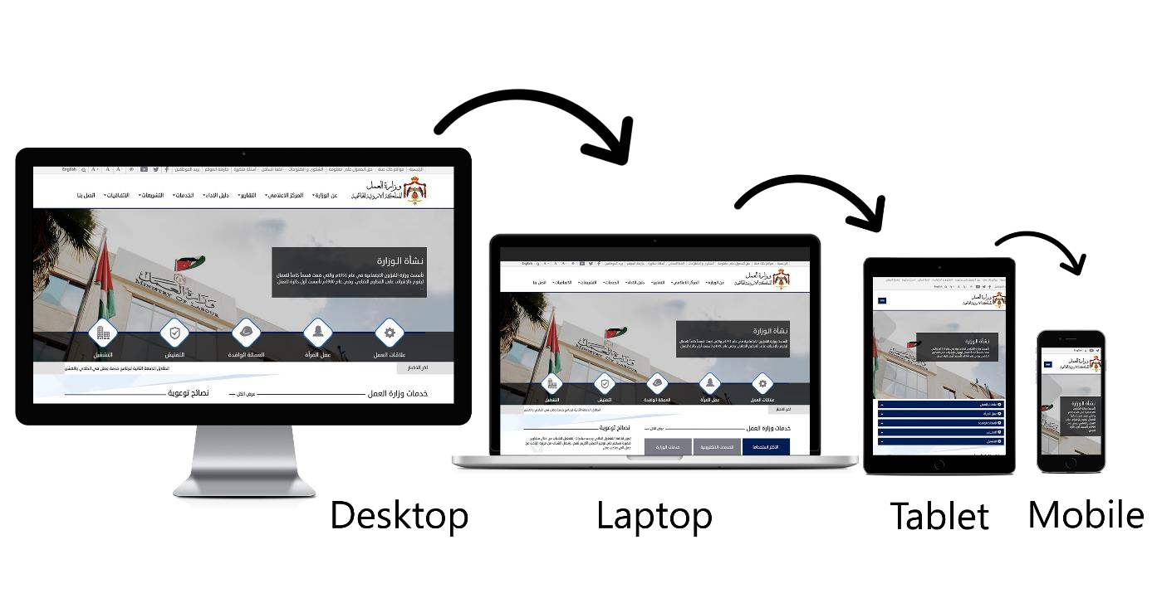

Figu
re
15

-

Responsive Web Design

Responsive sites use fluid grids. All page elements are sized by proportion, rather than pixels. For example, if there is a three columns page, it is not exactly how wide each should be, but rather how wide each should be in relation to the other columns. Column 1 should take up half the page, column 2 should take up 30%, and column 3 should take up 20%.
Responsive Web Design can be archived through Bootstrap, W3.CSS, Material Design, PureCSS, Materialize, etc.

Design for Mobile
Design for Mobile
Guideline ID: R.4.1
Development Lifecycle Stage:  ☒ Planning ☒ Design and Development ☒ | Deployment | ☒ | Operation
Website Service Category
☒ Informative Website ☒ e-Services Website

Website Pages: When using Responsive Web Design, the design should be for the content, where the page should show components based on priorities.
Wide Viewport | Narrow Viewport
Headline - Text - Text - Text Name Age Tel.  Question  - Answer  - Answer  - Answer | Headline  - Text  - Text  - Text  Name  Age  Tel.
Headline | Question  - Answer  - Answer  - Answer
Why | Headline
 | Why
Figure 16 - Standards and Responsive Website Pages
Logo:
- Logo should be designed with responsive frameworks and variable sizes; it should be able to resize itself to fit whatever available space has been provided for it without stretching.
Do
Responsive Logo

Don’t
Stretched Logo

- It is preferable to have the logo centered in the middle of the mobile design header.
Menu:
- Switch language button should be placed at the header of the mobile design. It shouldn’t be placed in the menu.
- In mobile design, the menus should be changed in style to a hamburger menu. As below:
Menu Name | Mobile Menu
Main Menu
Secondary Menu
Table 7- Mobile Menus
- Secondary Menu can be removed, where all its items are moved to the Main Hamburger Menu.
- In Arabic and English, the main menu should be placed on the right-side of the mobile design header and the secondary menu should be placed on the left-side.

The menu placement should appear in all pages in a constant location.
Search:
- Site search should appear in clear location at the mobile design header. Site search should not be placed in the menus.
- Site search should appear in all pages in a constant location.
Images:
- Unnecessary images that might distract the site visitor should be removed.
- Images should not be stretched or shrunk. All images should be displayed in their original dimension’s ratio.
Do
Original Image

Not Accepted
Stretched Image

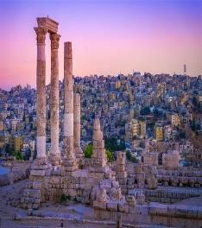

- Design images which is used for decoration purposes can be removed, resized, or cropped to enhance the design and website layout.
Accepted
Original Image

Accepted
Resized

Accepted
Cropped

Content images that are part of the content should be either resized or replaced with another image that is suitable for mobile web view. Cropping is forbidden.
Accepted
Original Image
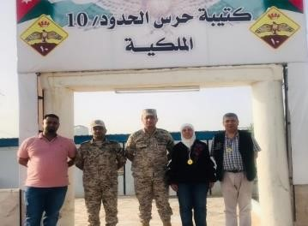

Accepted
Resized Image
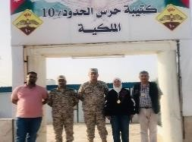

Not Accepted
Cropped Image
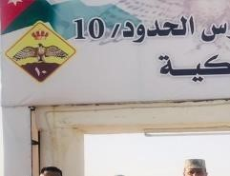

Buttons:
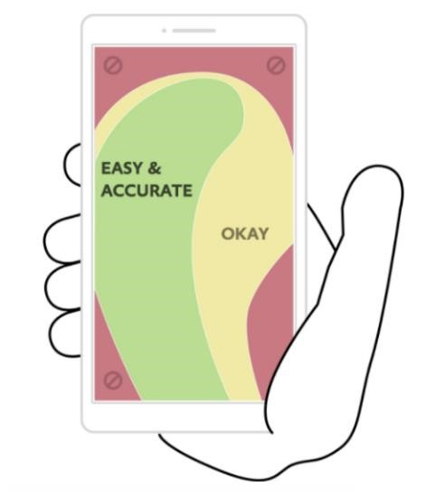
- Buttons need to be large enough to be tapped with a finger. Make sure you keep enough space between buttons for accurate clicking.
- Follow Thumb-Zone Rule stating that when locating buttons, avoid corners: It
is hard to reach those places while

holding a mobile device. The reach
Figure 14: Thumb-Zone Rule
decreases further as the screen size becomes larger. The most important elements and clickable buttons should be placed toward the middle of the screen.

Content
Content
Guideline ID: R.4.2
Development Lifecycle Stage:  ☐ Planning ☒ Design and Development | ☐ | Deployment | ☒ | Operation
Website Service Category
☒ Informative Website ☒ e-Services Website

Moving from multiple columns for large screen displays to a single column layout for very small screens is a typical trait of responsive sites, but layout change doesn’t stop with columns. Different layout will require different content approaches.
- Breadcrumbs should be removed from all pages.
Page content should be focusing on the content itself in order not to distract the site visitor with page’s side menus and ads banners. Side menus and ads banners should be removed from the mobile web display.
- For more text readability, empty spaces should be increased.

Website Security

To secure a website, you should secure the website application itself, infrastructure and connectivity. This standard document focuses on the minimum requirements of website application security only, whereby complying with these requirements is a must.
When applying and configuring a good website security, it will protect both the entity and the site visitor as below:
 | Government Entity |  | Site Visitor
•  •  •  •  • | DDoS attacks: DDoS can slow or crash  the site entirely.  Malware Protection: Malwares can be used to steal sensitive data, distribute spam, allow cybercriminals to access your site, and more.  Blacklisting: The website may remove search engine results due to malwares. Vulnerability Exploits: Cybercriminals can access a site and data stored on it by exploiting weak areas in a site, like an outdated plugin.  Defacement: This attack replaces your website’s content with malicious content. | •  •  •  • | Steal Data: Like account and payment information. Cybercriminals frequently go after visitor or customer data stored on a site.  Phishing Schemes: Some attacks take the form of web pages that look legitimate but are designed to trick the user into providing sensitive information. Session Hijacking: Cyber-attacks can take over a user’s session and force them to take unwanted actions on a site. Malicious Redirects: Certain attacks can redirect visitors from the site they intended to visit to a malicious website.

- SEO Spam: Unusual links, pages, and comments can be put on a site to confuse the site visitors and drive traffic to malicious websites.
Table 8 - Website Security

Based on the Ministry of Digital Economy and Entrepreneurship security standards, all websites should undergo a vulnerability assessment on annual basis. Remediation of security findings should be reflected to the website to ensure it is secure.
Entities should make sure to update their websites to comply with any future security technical guidelines that may be issued by the Ministry of Digital Economy and
Entrepreneurship.

OWASP Top 10
OWASP Top 10
Guideline ID: WS.5.1
Development Lifecycle Stage:  ☐ Planning ☒ Design and Development | ☒ | Deployment | ☒ | Operation
Website Service Category
☒ Informative Website ☒ e-Services Website

The website should be protected and secured, at minimum, against OWASP Top 10, where the OWASP Top 10 is a regularly-updated report outlining security concerns for web application security, focusing on the 10 most critical risks. The report is put together by a team of security experts from all over the world. According to OWASP Top 10 2017 report, below are the main
security risks:
The Open Web Application Security Project (OWASP) is a worldwide not-for-profit charitable organization focused on improving the security of software. For more information visit: https://www.owasp.org

For a technical and in-depth look at the OWASP Top 10 and how to prevent them, visit:
https://www.owasp.org/images/7/72/OWASP_Top_10-2017_%28en%29.pdf.pdf

- Injection: Injection attacks happen when untrusted data is sent to a code interpreter through a form input or some other data submission to a web application. For example:
An attacker could enter SQL database code into a form that expects a plaintext username.
If that form input is not properly secured, this would result in that SQL code being executed.
This is known as an SQL injection attack.
Injection attacks can be prevented by validating and/or sanitizing user-submitted data.

- Broken Authentication: Vulnerabilities in authentication (login) systems can give attackers access to user accounts and even the ability to compromise an entire system using an admin account.
- Sensitive Data Exposure: the website should protect sensitive data such as financial information and passwords. One popular method for stealing sensitive information is using a man-in-the-middle attack.
Sensitive data that should be encrypted include, but not limited to, the following:
  - User private data.
  - All communication channels connecting the website with external applications or
APIs.
  - User credentials.
Encrypting all sensitive data as well as disabling the caching of any sensitive information.

- XML External Entities (XEE): This is an attack against a web application that parses XML* input. This input can reference an external entity such as a hard drive, attempting to exploit a vulnerability in the parser.
XEE attacks can be prevented by having the website accept a less complex type of data, such as JSON.

- Broken Access Control: Broken access controls allow attackers to bypass authorization and perform tasks as though they were privileged users such as administrators.
- Security Misconfiguration: Security misconfiguration is the most common vulnerability on the list and is often the result of using default configurations or displaying excessively verbose errors.
- Cross-Site Scripting: Cross-site scripting vulnerabilities occur when the website allows users to add a custom code into a URL path or onto a website that will be seen by other users. This vulnerability can be exploited to run a malicious JavaScript code on a victim’s browser.
- Insecure Deserialization: This threat targets many web applications, which frequently serialize and reserialize data. Serialization means taking objects from the application code and converting them into a format that can be used for another purpose, such as storing the data to disk or streaming it. Deserialization is just the opposite: Converting serialized data back into objects the application can use.
- Using Components with Known Vulnerabilities: This threat occurs when using components such as libraries and frameworks form untrusted Component developers or not updating the components.
Always update the website components

- Insufficient Logging and Monitoring: OWASP recommends that websites should have logging and monitoring as well as incident response plans to ensure that they are made aware of attacks on their applications.

The average discovery time for a breach is around 200 days after it has happened.

HTTPS Protocol
HTTPS Protocol
Guideline ID: WS.5.2
Development Lifecycle Stage:  ☐ Planning ☐ Design and Development | ☒ | Deployment | ☐ | Operation
Website Service Category
☒ Informative Website ☒ e-Services Website

- All government websites should be switched to HTTPS protocol to make sure that site visitors are interacting with the proper server and nothing else can alter or intercept the content they are viewing.
- HTTPS certificate must be renewed every year.
HTTPS protocol will also improve the search ranking. Google is rewarding websites that use HTTPS.

Software Updates
Software Updates
Guideline ID: WS.5.3
Development Lifecycle Stage:  ☐ Planning ☐ Design and Development | ☐ | Deployment | ☒ | Operation
Website Service Category
☒ Informative Website ☒ e-Services Website

Failing to update the website’s software, security, and scripts when necessary is a sure way to allow intruders and malware to take advantage of the website.
- The website Content Management System must always be up-to-date, including all plugins and 3rd party components.
- The hosting environment updates and patches should be installed once they are released.

Restrict File Uploads
Restrict File Uploads
Guideline ID: W.5.4
Development Lifecycle Stage:  ☐ Planning ☒ Design and Development | ☐ | Deployment | ☒ | Operation
Website Service Category
☒ Informative Website ☒ e-Services Website

Having files uploaded on the website by site visitors are risky, where files could potentially contain a script that exploits vulnerabilities on the website when executed on the server.
- Files uploaded by visitors should be restricted in extension, where executable files should be banned.
- Acceptable types of file extensions should be specified and all other file types should be banned.
- Files uploaded by the site visitors should be stored in separated folders and databases.
- Double extension files should be banned.
- Where possible, use antimalware detection like Sandboxing technology as close as possible to the upload transactions.

Using Captcha
Using Captcha
Guideline ID: WS.5.5
Development Lifecycle Stage:  ☐ Planning ☒ Design and Development | ☐ | Deployment | ☐ | Operation
Website Service Category
☒ Informative Website ☒ e-Services Website

A CAPTCHA is a program that protects websites against bots by generating and grading tests that humans can pass but current computer programs cannot. For example: Humans can read distorted texts, but current computer programs can't.
- All website forms should contain captcha, where the captcha result should be successful before submission.
- Due to advance Bots and to make the form submission easier for the site visitor, it is recommended to use reCAPTCHA v2 by Google. Instead of a bulky questionnaire, site visitors only must click a button to identify themselves as human.
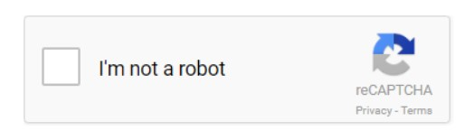
Figure 17 - reCAPTCHA v2 by Google
For more information on how to use reCAPTCHA, visit https://developers.google.com/recaptcha/

Users Passwords
Users Passwords
Guideline ID: WS.5.6
Development Lifecycle Stage:  ☐ Planning ☒ Design and Development | ☒ | Deployment | ☒ | Operation
Website Service Category
☒ Informative Website ☒ e-Services Website

It is crucial to use strong passwords to the hosing environment and website admin area, but equally also important to insist on good password practices for your site visitor to protect the security of their accounts.
- Strong password policy should be configurable, and strong passwords should be set, it is recommended to follow the below best practices at minimum:
  - Adopt the 8 4 Rule: This rule helps you to build strong passwords, where (8 = 8 characters’ minimum length) (4 = 1 lower case + 1 upper case + 1 number + 1 special character).
  - Use passwords that are at least 8 characters in length. 10 characters or longer are better.
  - No personal password allowed. o Use different passwords for different accounts.
  - Avoid dictionary words.

- Passwords should always be stored as encrypted values.
- Account should be periodically locked out after three failed logins.

Viruses and Malware
Viruses and Malware
Guideline ID: WS.5.7
Development Lifecycle Stage:  ☐ Planning ☐ Design and Development | ☒ | Deployment | ☒ | Operation
Website Service Category
☒ Informative Website ☒ e-Services Website

• Website and hosting environment should be well protected from viruses and malwares.

Adjust Default Settings
Adjust Default Settings
Guideline ID: WS.5.8
Development Lifecycle Stage:  ☐ Planning ☐ Design and Development | ☒ | Deployment | ☐ | Operation
Website Service Category
☒ Informative Website ☒ e-Services Website

- Default setting, account, configuration must be changed for both hosting environment and content management system.
- All default user names (like admin, default.aspx, index.aspx...etc.) should be renamed. The access
URL for admin panel/CMS, should also be renamed.

Error Messages
Error Messages
Guideline ID: WS.5.9
Development Lifecycle Stage:  ☐ Planning ☒ Design and Development | ☒ | Deployment | ☒ | Operation
Website Service Category
☒ Informative Website ☒ e-Services Website

- If an error occurs while the site visitor is browsing the website, the error messages should display minimum information on the error.
- Keep detailed errors in your server logs and show site visitors only the information they need.
- No data revealing the structure of any component of the website is allowed to show in the error message.

Secure APIs
Error Messages
Guideline ID: WS.5.10
Development Lifecycle Stage:  ☐ Planning ☒ Design and Development | ☒ | Deployment | ☒ | Operation
Website Service Category
☒ Informative Website ☒ e-Services Website

API stands for Application Programming Interface, which is used to access data and features of other applications, services, or operating systems.
- APIs should always be HTTPS to avoid man-in-the-middle-attacks.
- Passwords should never be stored as plain text, they should always be hashed in addition; a symmetric encryption must be strictly avoided.
- Use OAuth, where using OAuth2 is recommended, which enables a third-party
application to obtain limited access to the service.
- Tokens should have an expiration time to reduce the breach impact if the token was leaded.
- Based on the API business, the API should have a limitation on how many times the client is allowed to call the API.
- The Parameters must always be validated to avoid SQL Injection.
- IDs must be opaque and globally unique to prevent fusking attack. For example: Rather than using the ID “1002“ and “1003“ use “r5t844fsg6fssf2vfrb9bd8”.
- IP address filtration is a must when applicable, where the API IP address can be only accessed for certain IPs.
- Adding Timestamp in Request to enable the server to compare the current timestamp to the request timestamp, and only accept the request if it is within a reasonable timeframe.
- Information shouldn’t be exposed in the URL. For example: Usernames, passwords,
session tokens, API keys, etc...

